% Create the rigid body tree model using URDF file
arm = importrobot('simple_v2modified.urdf');
initialGuess = arm.homeConfiguration; % Return the home Configuration of the model
% Create an inverse kinematics solver object for the rigid body tree model
ik = robotics.InverseKinematics('RigidBodyTree', arm);
position = [0.1905 -0.0080 0.1315];%[0 0 0]; % The desired end-effector position
tform = trvec2tform(position); % Create a homogeneous transform from the desired end-effector position
% Calculate the inverse kinematics solution using the "ik" solver
% Use desired weights for solution (First three for orientation, last three for position)
% Since it is a 2 DOF we put weights only on x and y position
weights = [0 0 0 1 1 0];
[QSol, info] = ik('ISO 7045 - M5 x 6 - Z --- 6S-3',tform,weights,initialGuess);
JointStates = [QSol.JointPosition]
show(arm,QSol)
JointStates =
3.6592 0
ans =
Axes (Primary) with properties:
XLim: [-0.5000 0.5000]
YLim: [-0.5000 0.5000]
XScale: 'linear'
YScale: 'linear'
GridLineStyle: '-'
Position: [0.1300 0.1100 0.7750 0.8150]
Units: 'normalized'
Use GET to show all properties
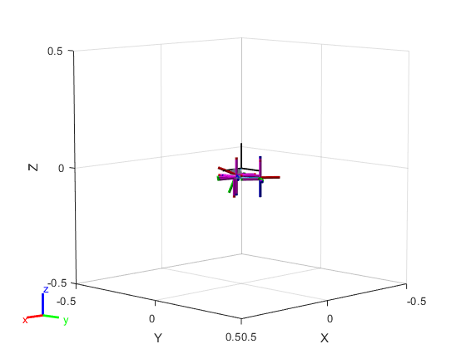
Published with MATLAB® R2018a

